**Department of Computer Science & Engineering, SDMCET, Dharwad-2**



**AOOP Assignment Submission Report**

**[Submitted as part of CTA Assignment No-1]**

|  |  |  |  |
| --- | --- | --- | --- |
| Course: | Advanced Object-Oriented Programming | Course Code: | 18UCSE508 |
| Semester: | V | Division: | A |

Submitted by:

|  |  |  |  |
| --- | --- | --- | --- |
| USN: | 2SD20CS057 | Name: | Mukund V B |

**1. Problem Definition:**

**Write a Java program to build the GUI application using JavaFX for the following requirements:**

**a) Read user name and password using appropriate JavaFX controls.**

**b) Validate the input. If user name and password are matched with the assumed values, then display the welcome scene with proper text.**

**c) If user name and password don’t match, then raise appropriate exception.**

**2. Java Program:**

: import javafx.application.Application;

import javafx.geometry.Pos;

import javafx.scene.Scene;

import javafx.scene.control.Button;

import javafx.scene.control.Label;

import javafx.scene.control.PasswordField;

import javafx.scene.control.TextField;

import javafx.scene.layout.FlowPane;

import javafx.scene.layout.HBox;

import javafx.scene.layout.VBox;

import javafx.stage.Stage;

public class Question1 extends Application {

public static void main(String[] args) {

launch(args);

}

@Override

public void start(Stage myStage) {

// TODO Auto-generated method stub

myStage.setTitle("UserName and PassWord");

VBox vbox = new VBox();

HBox hbox = new HBox();

Label label = new Label("User Name : ");

TextField tf = new TextField();

// layout for component

HBox hbox2 = new HBox();

Label label2 = new Label(" password : ");

PasswordField pass = new PasswordField();

// to keep components center

hbox.setAlignment(Pos.CENTER);

hbox2.setAlignment(Pos.CENTER);

//adding components to the horizontal layout

hbox.getChildren().addAll(label,tf);

hbox2.getChildren().addAll(label2,pass);

// creating the button

Button btn = new Button("Submit");

// label for show results

Label label1 = new Label("");

// assumed value for validation

String username = "20cs057";

String password = "Mukund";

// setting action on button

btn.setOnAction(e -> {

// getting the values from the field

String EUsername = tf.getText();

String Epassword = pass.getText();

// if entered username and password are equal then create a new welcome

Scene

if(username.equals(EUsername) && password.equals(Epassword)) {

// label1.setText(" : WELCOME : ");

FlowPane flowpane = new FlowPane();

flowpane.setAlignment(Pos.CENTER);

Label welcome = new Label(": Welcome :");

flowpane.getChildren().add(welcome);

Scene myScene1 = new Scene(flowpane,500,300);

myStage.setScene(myScene1);

}else {

try {

throw new MyException();

}catch(MyException e1){

label1.setText(e1.toString());

}

}

});

// adding horizontal components to the main vertical layout

vbox.getChildren().addAll(hbox,hbox2,btn,label1);

// adding layout to the scene

Scene myScene = new Scene(vbox,500,300);

// sapcing between the vartical components

vbox.setSpacing(10);

vbox.setAlignment(Pos.CENTER);

myStage.setScene(myScene);

myStage.show();

}

}

class MyException extends Exception{

public String toString() {

return "Invaid UserName and Password";

}

}

**Screen Shots of Execution:**

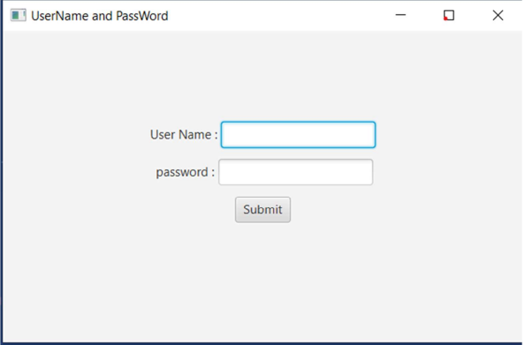

**2.Write a Java program to build the GUI application using JavaFX for the following requirements:**

**a) Create a Menu control to display the menu items: File, Edit & Help.**

**b) Create sub menus in the order: File → New, Open & Save. Edit → Cut, Copy & Paste. Help → Help Centre, About Us The program must use Mnemonics and Accelerators (wherever appropriate) to Menu Items.**

**2. Java Program:**

package application;

import javafx.application.Application;

import javafx.scene.Group;

import javafx.scene.Scene;

import javafx.scene.control.Menu;

import javafx.scene.control.MenuBar;

import javafx.scene.control.MenuItem;

import javafx.scene.paint.Color;

import javafx.stage.Stage;

public class Question2 extends Application {

public void start(Stage stage) {

//Creating file menu

Menu file = new Menu("File");

//Creating file menu items

MenuItem item1 = new MenuItem("New");

MenuItem item2 = new MenuItem("Open");

MenuItem item3 = new MenuItem("Save");

//Adding all the menu items to the file menu

file.getItems().addAll(item1, item2, item3);

//Creating edit menu

Menu edit = new Menu("Edit");

//Creating fileList menu items

MenuItem item6 = new MenuItem("Cut");

MenuItem item7 = new MenuItem("Copy");

MenuItem item8 = new MenuItem("Paste");

//Adding all the items to File List menu

edit.getItems().addAll(item6, item7, item8);

//Creating help menu

Menu help = new Menu("Help");

MenuItem item9 = new MenuItem("Help center");

MenuItem item10 = new MenuItem("About Us");

help.getItems().addAll(item9, item10);

//Creating a menu bar

MenuBar menuBar = new MenuBar();

menuBar.setTranslateX(200);

menuBar.setTranslateY(20);

//Adding all the menus to the menu bar

menuBar.getMenus().addAll(file, edit, help);

//Setting the stage

Group root = new Group(menuBar);

Scene scene = new Scene(root, 595, 200, Color.BEIGE);

stage.setTitle("Menu Bar Example");

stage.setScene(scene);

stage.show();

}

public static void main(String args[]){

launch(args);

}

}

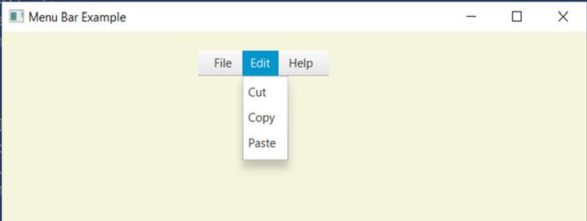**Screen Shots of Execution:**

1. **Problem Definition:**

**Write a Java program to build the GUI application using JavaFX for the following requirements:**

**a) Create Context menu involving the menu items in the order: New & View.**

**b) Create sub menus for the above main context menu: New → File, Folder & Image. View → Large, Medium & Small. The context menu must be displayed on right-click of the mouse button.**

**Java Program:**

**package application;**

import java.io.FileNotFoundException;

import javafx.application.Application;

import javafx.geometry.Insets;

import javafx.scene.Group;

import javafx.scene.Scene;

import javafx.scene.control.Button;

import javafx.scene.control.ContextMenu;

import javafx.scene.control.MenuItem;

//import javafx.scene.control.TextField;

import javafx.scene.layout.HBox;

import javafx.scene.paint.Color;

import javafx.stage.Stage;

public class Question3 extends Application {

public void start(Stage stage) throws FileNotFoundException {

//Creating the image view

Button button1 = new Button("new");

Button button2 = new Button("view");

//TextField textField = new TextField();

//Creating a context menu

ContextMenu contextMenu1 = new ContextMenu();

//Creating the menu Items for the context menu

MenuItem item1 = new MenuItem("file");

MenuItem item2 = new MenuItem("folder");

MenuItem item3 = new MenuItem("image");

contextMenu1.getItems().addAll(item1, item2,item3);

//Adding the context menu to the button and the text field

ContextMenu contextMenu2 = new ContextMenu();

//Creating the menu Items for the context menu

MenuItem item11 = new MenuItem("large");

MenuItem item21 = new MenuItem("medium");

MenuItem item31 = new MenuItem("small");

contextMenu2.getItems().addAll(item11, item21,item31);

// textField.setContextMenu(contextMenu);

button1.setContextMenu(contextMenu1);

button2.setContextMenu(contextMenu2);

HBox layout = new HBox(20);

layout.setPadding(new Insets(15, 15, 15, 100));

layout.getChildren().addAll( button1,button2);

//Setting the stage

Scene scene = new Scene(new Group(layout), 595, 150, Color.BEIGE);

stage.setTitle("CustomMenuItem");

stage.setScene(scene);

stage.show();

}

public static void main(String args[]){

launch(args);

}

}

**Screen Shots of Execution:**

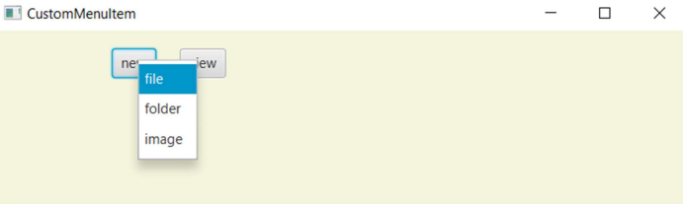

1. **Problem Definition:**

**Write a JavaFX program that produces the following output when executed and displays Dialog Box**

**(as shown in Figure.2) on click of Register button (as shown in Figure.1):**

**Java Program:**

import javafx.application.Application;

import javafx.geometry.Insets;

import javafx.geometry.Pos;

import javafx.scene.control.Dialog;

import javafx.scene.control.DialogPane;

import javafx.scene.Scene;

import javafx.scene.control.Button;

import javafx.scene.control.CheckBox;

import javafx.scene.control.ChoiceBox;

import javafx.scene.control.DatePicker;

import javafx.scene.layout.BorderPane;

//import javafx.scene.control.Button;

import javafx.scene.image.Image;

import javafx.scene.image.ImageView;

import javafx.scene.control.ButtonType;

import javafx.scene.control.Label;

//import javafx.scene.control.Label;

//import javafx.scene.control.ListView;

import javafx.scene.control.RadioButton;

import javafx.scene.layout.GridPane;

import javafx.scene.text.Text;

import javafx.scene.control.TextField;

import javafx.scene.control.ToggleGroup;

//import javafx.scene.control.ToggleButton;

import javafx.stage.Stage;

public class Question4 extends Application {

@Override

public void start(Stage stage) {

//Label for name

BorderPane root = new BorderPane();

stage.setTitle(" JavaFX Registration form");

// label headerLabel = new Label("Registration Form");

Label label = new Label("Employee Registration Form");

// Object root;

root.setTop(label);

//root.setAlignment(label, Pos.CENTER);

Text nameLabel = new Text("Enter your Name");

//Text field for name

TextField nameText = new TextField();

//Label for date of birth

Text dobLabel = new Text("Enter Date of birth");

//date picker to choose date

DatePicker datePicker = new DatePicker();

//Label for gender

Text genderLabel = new Text("Enter your Gender");

//Toggle group of radio buttons

ToggleGroup groupGender = new ToggleGroup();

RadioButton maleRadio = new RadioButton("male");

maleRadio.setToggleGroup(groupGender);

RadioButton femaleRadio = new RadioButton("female");

femaleRadio.setToggleGroup(groupGender);

Text selectyourqualificationLabel = new Text("Select your qualification");

//check box for education

CheckBox ugCheckBox = new CheckBox("UG");

ugCheckBox.setIndeterminate(false);

//check box for education

CheckBox pgCheckBox = new CheckBox("PG");

pgCheckBox.setIndeterminate(false);

CheckBox phdCheckBox = new CheckBox("PhD");

phdCheckBox.setIndeterminate(false);

//Label for location

Text locationLabel = new Text("select your state");

//Choice box for location

ChoiceBox locationchoiceBox = new ChoiceBox();

locationchoiceBox.getItems().addAll

("Karnataka", "Tamilnadu", "Delhi", "Mumbai", "AP");

Button buttonRegister = new Button("Register");

//Creating a Grid Pane

GridPane gridPane = new GridPane();

//Setting size for the pane

gridPane.setMinSize(500, 500);

//Setting the padding

gridPane.setPadding(new Insets(10, 10, 10, 10));

//Setting the vertical and horizontal gaps between the columns

gridPane.setVgap(5);

gridPane.setHgap(5);

//Setting the Grid alignment

gridPane.setAlignment(Pos.CENTER);

//Arranging all the nodes in the grid

gridPane.add(nameLabel, 0, 0);

gridPane.add(nameText, 1, 0);

gridPane.add(dobLabel, 0, 3);

gridPane.add(datePicker, 1, 3);

gridPane.add(genderLabel, 0, 2);

gridPane.add(maleRadio, 1, 2);

gridPane.add(femaleRadio, 2, 2);

// gridPane.add(reservationLabel, 0, 3);

//gridPane.add(yes, 1, 3);

gridPane.add(selectyourqualificationLabel , 0, 5);

gridPane.add(ugCheckBox, 1, 5);

gridPane.add(pgCheckBox, 2, 5);

gridPane.add(phdCheckBox,3, 5);

gridPane.add(locationLabel, 0, 4);

gridPane.add(locationchoiceBox, 1, 4);

gridPane.add(buttonRegister, 1, 8);

//Styling nodes

buttonRegister.setStyle(

"-fx-font: normal bold 15px 'serif' " );

nameLabel.setStyle("-fx-font: normal bold 15px 'serif' ");

dobLabel.setStyle("-fx-font: normal bold 15px 'serif' ");

genderLabel.setStyle("-fx-font: normal bold 15px 'serif' ");

selectyourqualificationLabel.setStyle("-fx-font: normal bold 15px 'serif' ");

locationLabel.setStyle("-fx-font: normal bold 15px 'serif' ");

12

gridPane.setStyle("-fx-background-color: white;");

buttonRegister.setOnAction(e->{

// creating a dialog box

Dialog dialog = new Dialog();

dialog.setTitle("Registration Successfull");

dialog.setHeaderText("Registration Status");

dialog.setContentText("Employee Registration is successfull");

// adding image to the dialog box

// Image img = new Image("",50,50,true,true);

//ImageView imageview = new ImageView(img);

//

//dialog.setGraphic(imageview);

// adding button to the dialog box

dialog.getDialogPane().getButtonTypes().add(ButtonType.OK);

dialog.show();

});

Scene scene = new Scene(gridPane);

// stage.setTitle("Registration Form");

//Adding scene to the stage

stage.setScene(scene);

//Displaying the contents of the stage

stage.show();

}

public static void main(String args[]){

launch(args);

}

}

}

**Screen Shots of Execution:**

